Experiment 2: Introduction to Simulink

Objective: To be familiar with the basics of Simulink software

Background information
Simulink is an interactive tool for modeling, simulating, and analyzing dynamic systems. It enables the users to build graphical block diagrams to simulate and evaluate system performance, and to refine system designs. Simulink integrates seamlessly with MATLAB, providing the users with immediate access to an extensive range of analysis and design tools. These benefits make Simulink a powerful tool for control system design, DSP design and communications system design.

Procedure 1
- Activate the ‘Simulink Library Browser’ by clicking the Simulink icon and then the Blank Model on the menu bar of the MATLAB window.
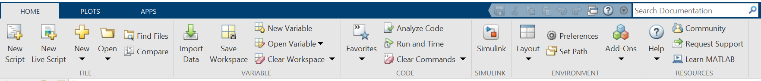

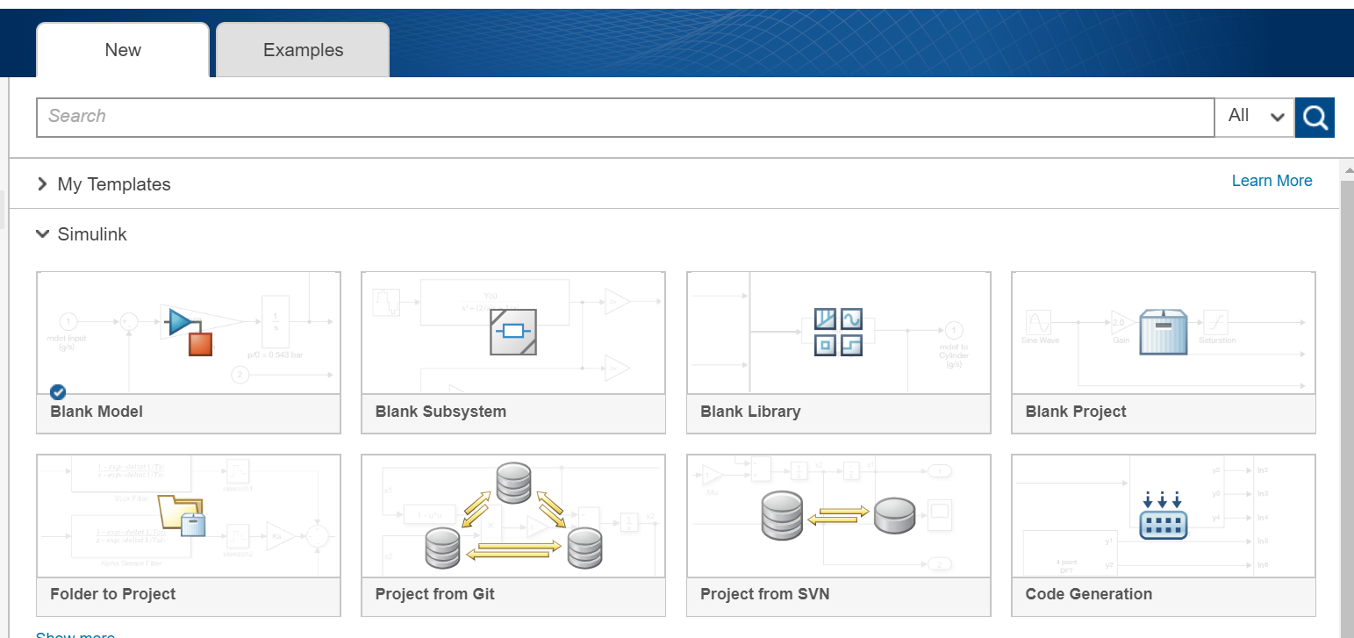
Click to open the Library Browser icon.

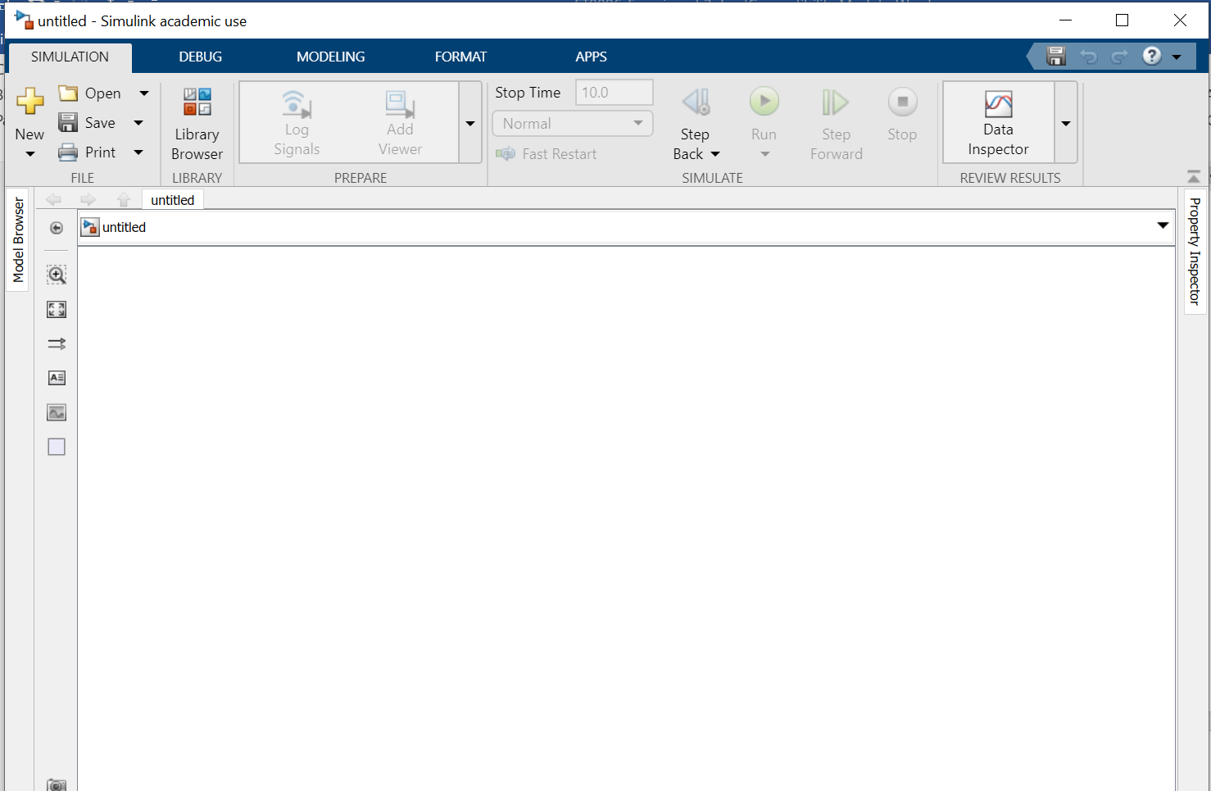

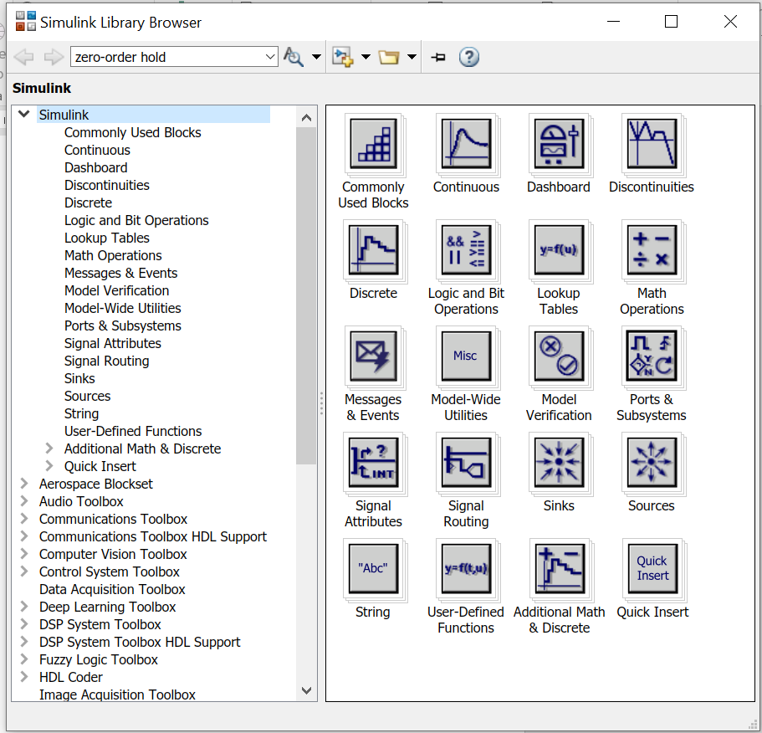

- Click the ‘NEW’ icon.

- Click and drag the ‘Sine Wave’ block from the Simulink Library Browser to the model.

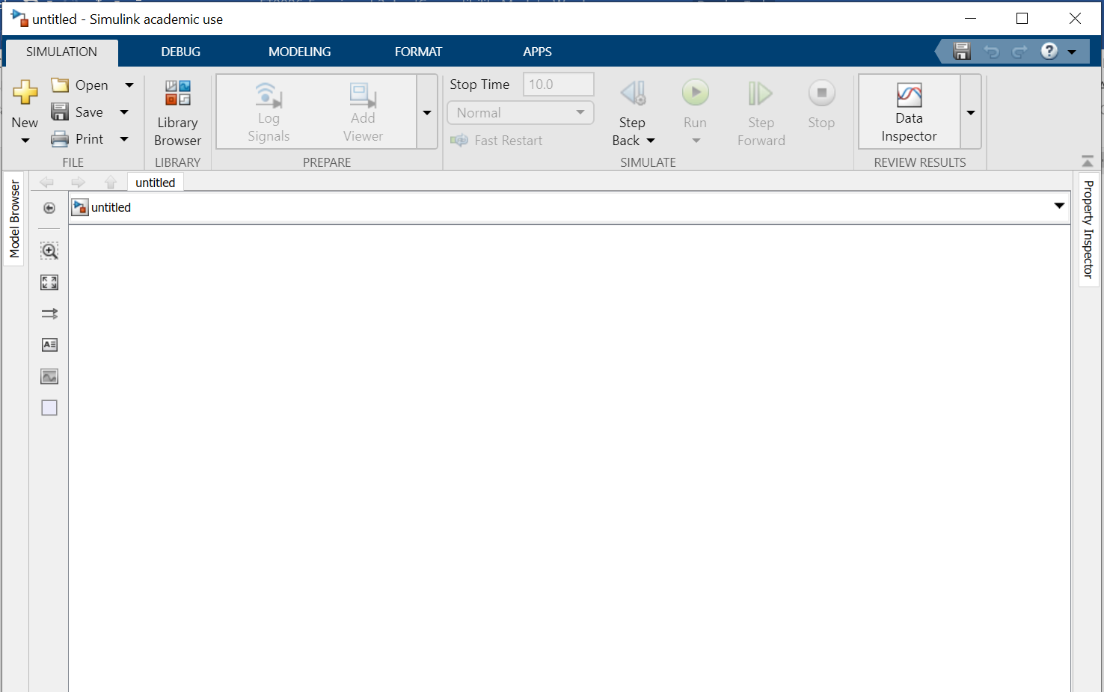
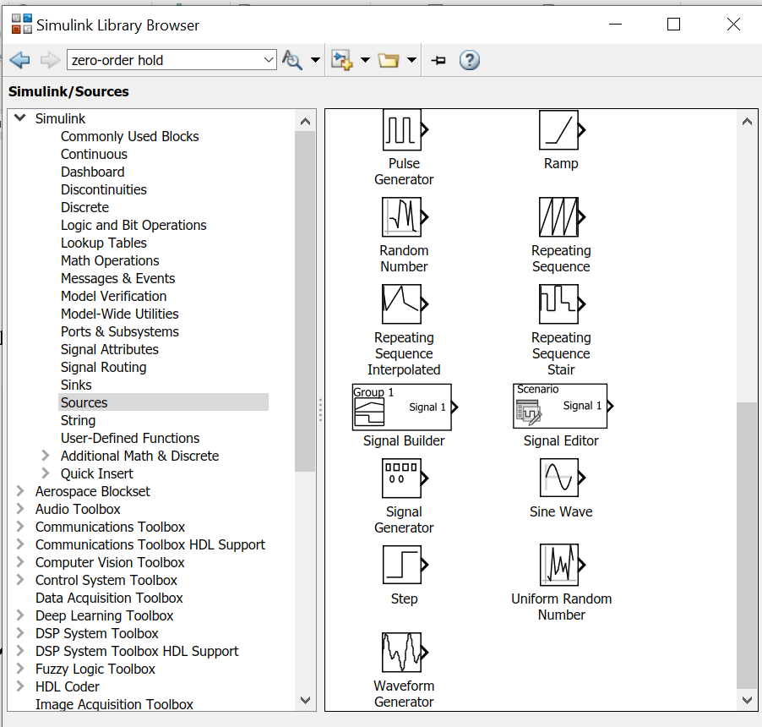

- Click to open the ‘Math’ library.

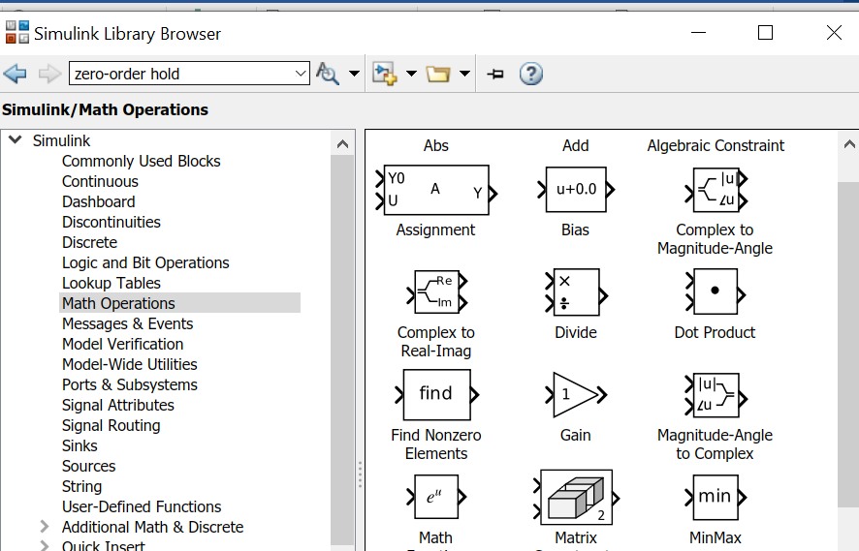

- Click and drag the ‘Gain’ block in the ‘Math’ library to the model.

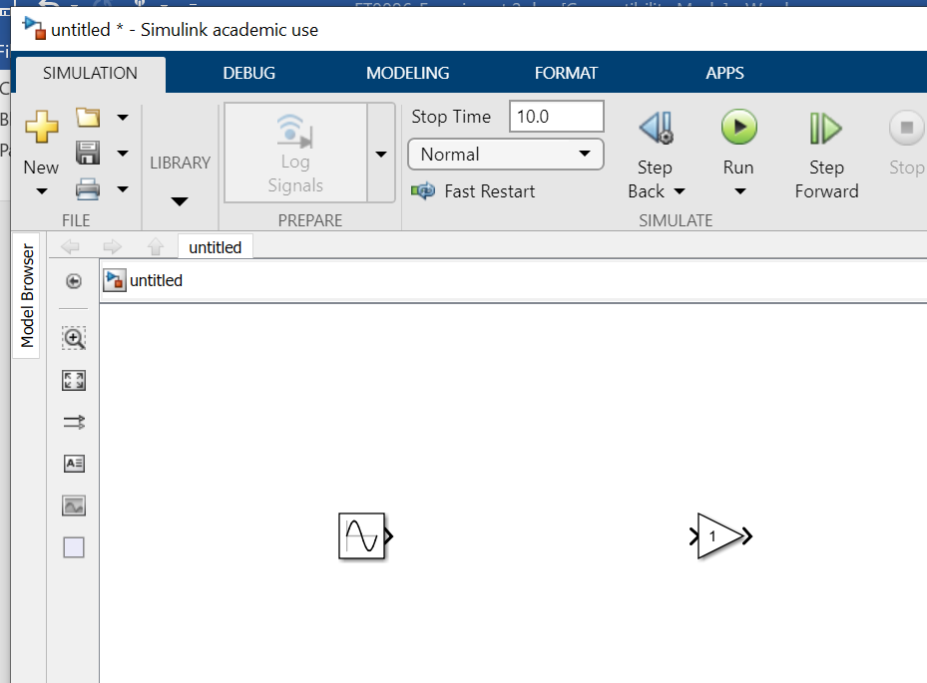
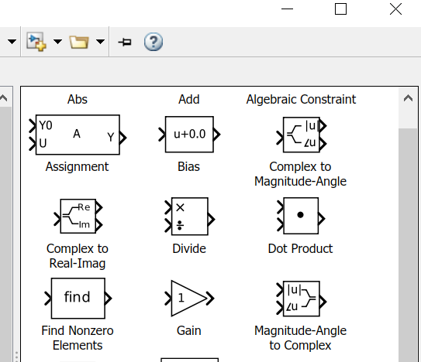

Click and drag to link up the ‘Sine Wave’ block and the ‘Gain’ block.

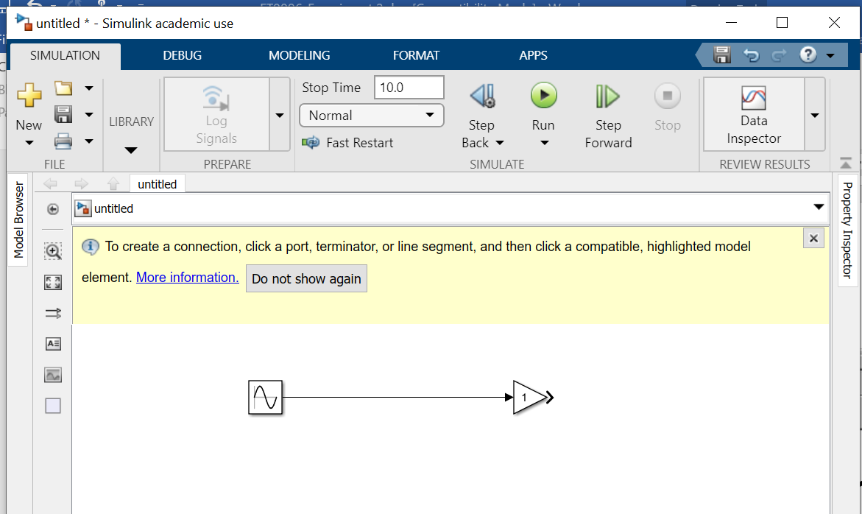

- Click to open the ‘Sinks’ library. Click and drag the ‘Scope’ block from the ‘Sinks’ library to the model. Click and drag to link up the ‘Gain’ block and the ‘Scope’ block.

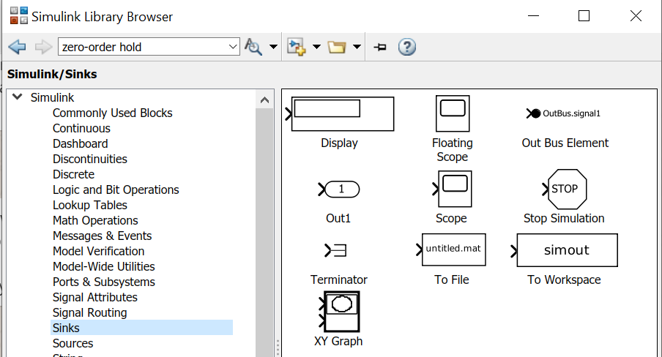

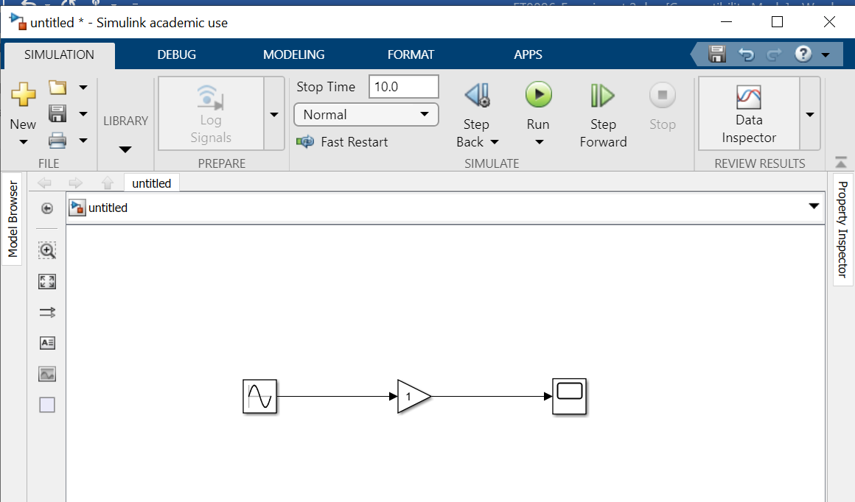

- Click the ‘Run’ icon to start the simulation.

- When simulation is completed, a ‘ding’ sound will be heard. Double click the ‘Scope’ block to view the waveform. Double click the ‘Gain’ block to launch the ‘Block Parameter’ window. Try change the gain to 5. Click the ‘Start simulation’ icon again. If you cannot see the Scope window, double click the ‘Scope’ block to view the waveform again. Record your result. Is the amplitude of the waveform equal to 5 now?

- Click and drag another ‘Scope’ block from the ‘Sink’ Library to the model. Right click and drag to link up the ‘Sine Wave’ block and the ‘Scope1’ block as shown below. You can click on the icon of the scope and “…” will appear on the scope. Choose the option to show the name of the scope.

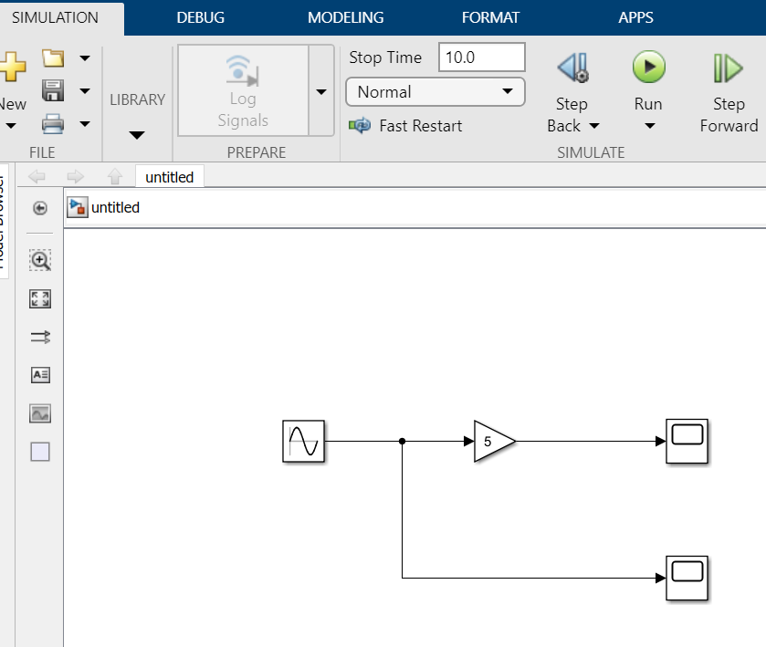
Right click and drag
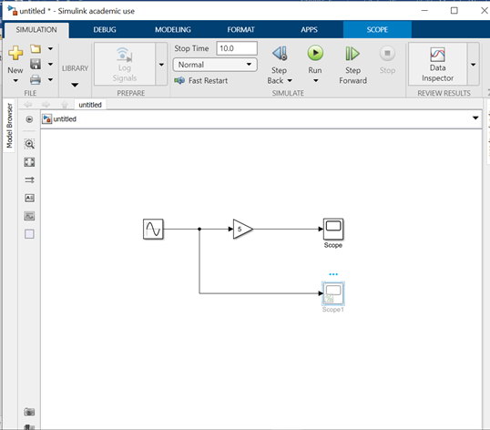

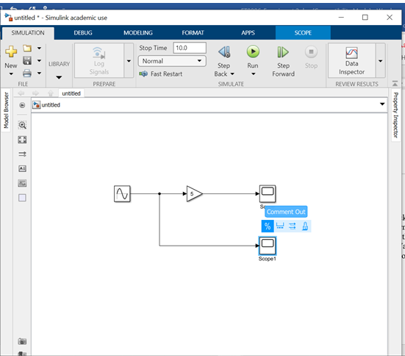

- Click the ‘Run’ icon again to start the simulation. Double click the ‘Scope1’ block and the ‘Scope’ block to record the input and output waveforms. If the two scope windows overlap each other, separate them. Check whether the input and output amplitudes are correct. Select and clear (or delete) the ‘Sine Wave’ block. Save it under an appropriate filename such as sine1.slx.

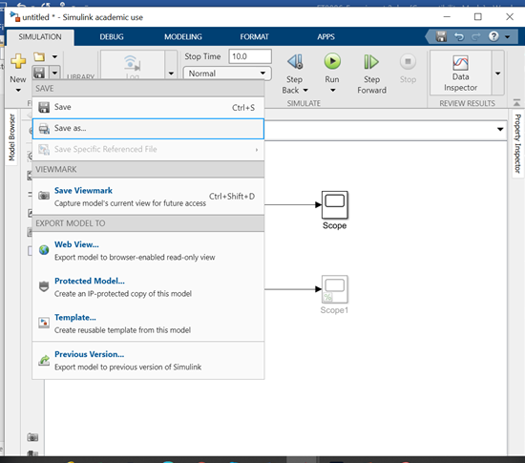

- Click on the Sine Wave icon. Record the frequency which is shown in radian/sec. Convert it to Hz.

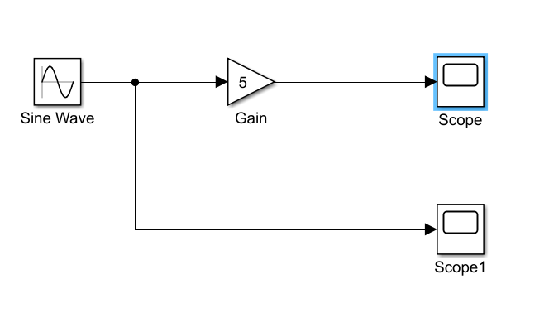

- Click the ‘Run’ icon again to start the simulation. Click ‘Scope’ icon.

- Click ‘Tool’ and select Signal Statistics. Record the max and min values of the signal.

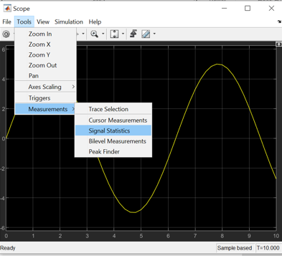

- Click Cursor Measurements and Settings. Check the Horizontal and Vertical under Cursor Measurement. Adjust for vertical cursors 1 and 2 at different peak of the Sine wave and find out the frequency value.

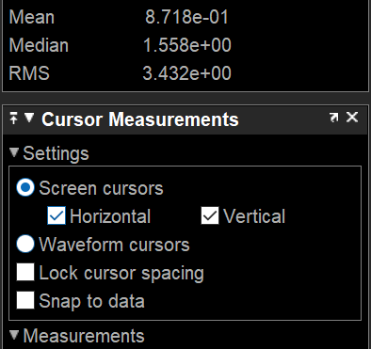

- This is an independent portion for the students to create the following Simulink blocks. Only the constant value is 1 and the icon can be obtained from the Sources and Add icon from the Math Operations. The rest is the default value. Click the scope to check whether the sine wave is shifted positively by 1. Note that Add is under Math Operations. Click Run and double click on Scope to see whether you obtain a sine wave shifted DC by 1.

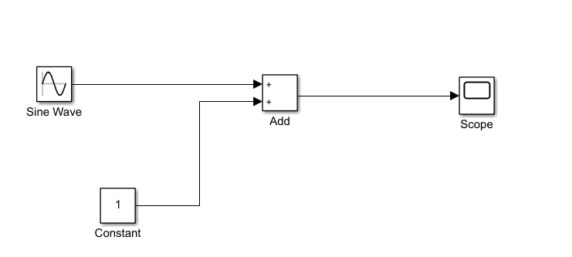

- This is an independent portion for the students to create the following Simulink blocks. The source is now ‘Pulse Generator’ block. Run simulation and observe the input and output waveforms.

